**Policy workstream Overview**

The Policy Workstream drives the advancement of Rwanda's circular economy for food through ongoing strategic collaboration and informed policymaking. This is achieved through two key activities:

1. **Multi-Stakeholder Platform (MSP):** Established in March 2023, the MSP promotes stronger collaboration and coordination among project partners and stakeholders—including policymakers, the private sector, and civil society—to enhance food circularity at the national level. Currently comprising 40 members, the MSP fosters a collaborative environment where SMEs and diverse stakeholders regularly share insights and strategies to drive the circular economy forward. It leverages existing data to inform interventions continually, identifying areas for improvement and growth within Rwanda's circular food economy. The platform serves as a central, ongoing forum for discussing and validating policy initiatives, ensuring that recommendations are grounded in stakeholder input and aligned with national priorities.

*Governance structure*

Co-Chair: **MINAGRI**

Co-Chair: **MoE**

Secretariat: **CPCIC**

*Supported by:* **ACEA, ACEN, WRI and RESONNANCE**

**Members**

Focal points from the Private Sector/SMEs

**Members**

Focal points from development partners and Civil Society Organisations

**Members**

Focal points from the public sector institutions

**Members**

Focal points from Academic and Research Institutions

1. **Policy Dialogue and Advocacy:** This activity actively utilizes insights from the MSP to craft and validate policy briefs, recommendations, and action points aimed at creating an enabling environment for a circular food economy in Rwanda.

**The approach:**

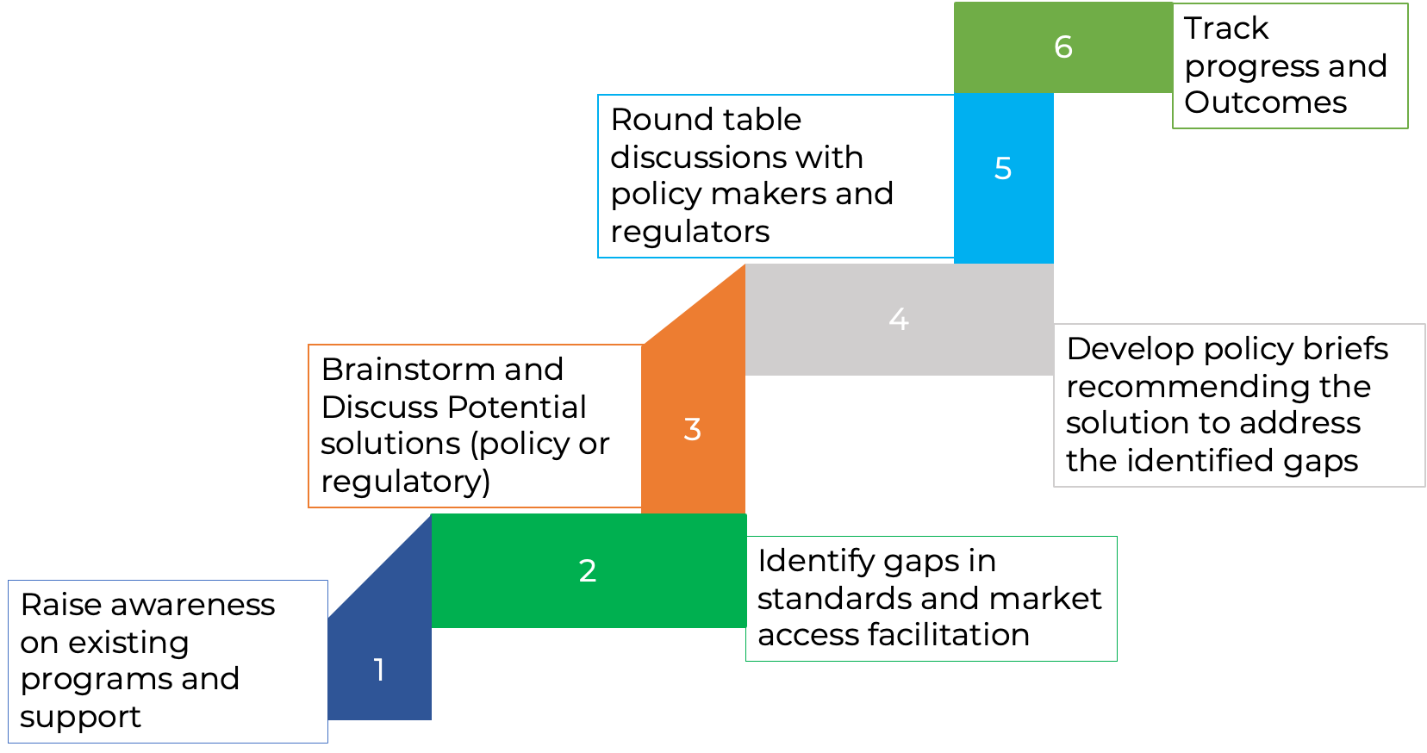

**Quarterly Multi-Stakeholder Platform Meetings:**

* **June 2023:** The first Multistakeholder platform meeting was held.

**Photos** [First Multistakeholder Platform Meeting for Circular Food Systems for Rwanda | Flickr](https://www.flickr.com/photos/197952320@N04/albums/72177720309213632)

* **September 2023:** The second meeting focused on market access and certification processes for circular products in the agrifood sector.

**Photos** [2nd Multi-Stakeholder Platform for Circular Food Systems for Rwanda | Flickr](https://www.flickr.com/photos/197952320@N04/albums/72177720311561873/)

* **December 2023:** The third meeting discussed the role of policy research and data for improved advocacy on circular food systems transformation in Rwanda.

**Photos** [3rd Multi-Stakeholder Platform Meeting for Circular Food Systems for Rwanda | Flickr](https://www.flickr.com/photos/197952320@N04/albums/72177720313524736/)

* **June 2024:** The fourth meeting focused on access to finance for circular businesses in the food systems in Rwanda, identified as a priority challenge for SMEs in circular food systems.

**Photos** [4th Multi-Stakeholder Platform Meeting for Circular Food Systems for Rwanda project, Kigali Marriot Hotel, 18th june 2024 | Flickr](https://www.flickr.com/photos/197952320@N04/albums/72177720319179387)